Institute of Computer Technology

B. Tech Computer Science and Engineering

Subject: OOP (2CSE303)

**Assignment-1**

**1. Consider an integer Z, print its first 10 multiples. Each multiple through**

**i where 0 < i < 11, should be printed on a new line as: Z x i=value.**

**Constraints:**

**5 < Z < 41**

***SOLUTION***

package assignment_1;

/**

*

* @author yashp

*/

import java.util.*;

public class OOPA1Q1 {

public static void main(String[] args) {

Scanner yash = new Scanner(System.in);

int Z, i, ans;

System.out.print("\nEnter element whose first 10 multiple you want to find(5<Z<41): ");

Z = yash.nextInt();

if (Z > 5 && Z < 41) {

for (i = 1; i < 11; i++) {

ans = Z * i;

System.out.println(Z + "x" + i + "=" + ans);

}

} else {

System.out.println("Entered element does not satsify the given condition.");

}

}

}

***OUTPUT***

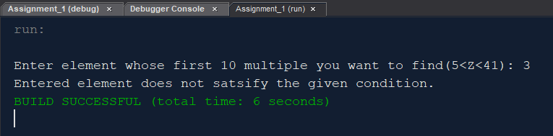

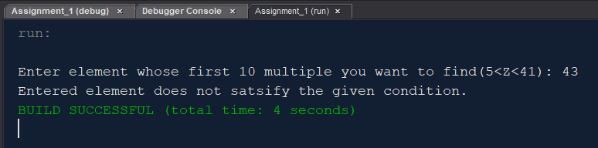

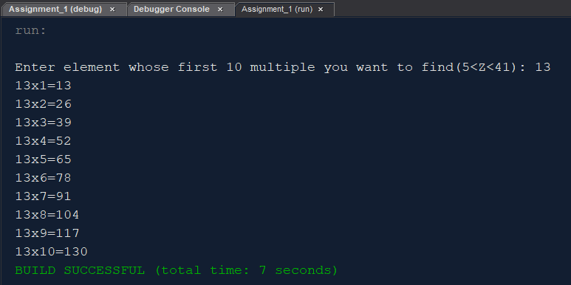

**2. Arjun would like to withdraw X Rs. from an ATM. The cash machine will only accept the transaction if X is a multiple of 5, and Pooja's account balance has enough cash to perform the withdrawal transaction (including bank charges). For each successful withdrawal the bank charges 0.50 Rs. Calculate Pooja's account balance after an attempted transaction.**

***SOLUTION***

package assignment_1;

/**

*

* @author yashp

*/

import java.util.*;

public class OOPA1Q2 {

public static void main(String[] args) {

Scanner yash = new Scanner(System.in);

double bal, amt;

System.out.print("Enter balance in Pooja's accout: ");

bal = yash.nextDouble();

System.out.print("Enter Amount Arjun want to withdraw: ");

amt = yash.nextDouble();

if (amt + 0.50 < bal) {

if (amt % 5 == 0) {

System.out.print("WITHDRAW TRANSACTION SUCCESSFUL!!");

System.out.print("\nBalance in account: " + (bal - amt - 0.5));

} else {

System.out.print("Can not withdraw transaction because withdraw amount is not multiple of 5.");

System.out.print("\nBalance in Pooja's account: " + bal);

}

} else {

System.out.print("Pooja's account does not have enough balance.");

}

System.out.print("\n");

}

}

***OUTPUT***

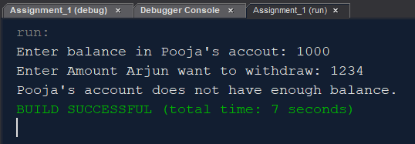

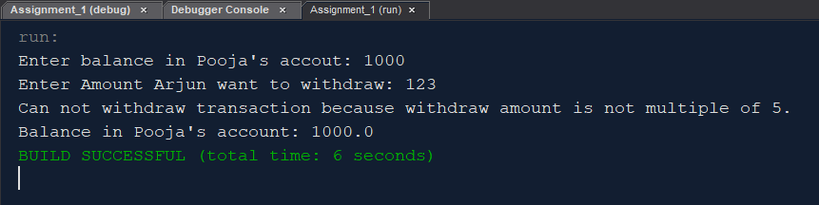

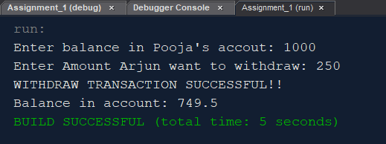

**3. Write a program to print the names of students by creating a Student class. If no name is passed while creating an object of Student class, then the name should be "Unknown", otherwise the name should be equal to the String value passed while creating object of Student class.**

***SOLUTION***

package assignment_1;

/**

*

* @author yashp

*/

import java.util.*;

class student {

student() {

System.out.print("Unknown");

}

student(String name) {

System.out.print("Name entered: " + name);

}

}

public class OOPA1Q3 {

public static void main(String[] args) {

Scanner yash = new Scanner(System.in);

char ch;

String name;

System.out.print("Do you want to pass name(y/n): ");

ch = yash.next().charAt(0);

if (ch == 'y' || ch == 'Y') {

System.out.print("Enter name: ");

name = yash.next();

student obj = new student(name);

} else {

student obj1 = new student();

}

System.out.print("\n");

}

}

***OUTPUT***

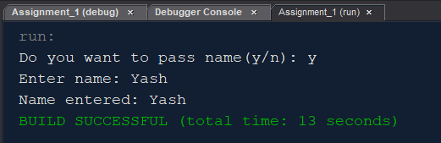

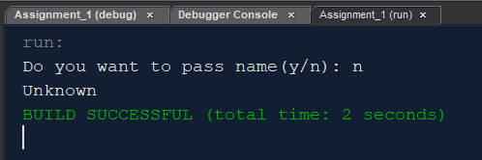

**4. Take 10 integer inputs from user and print the following: number of positive numbers**

**number of negative numbers**

**number of odd numbers**

**number of even**

**numbers number of 0s.**

***SOLUTION***

package assignment_1;

/**

*

* @author yashp

*/

import java.util.*;

public class OOPA1Q4 {

public static void main(String[] args) {

Scanner yash = new Scanner(System.in);

int pos = 0, neg = 0, odd = 0, even = 0, zero = 0;

int arr[] = new int[10];

System.out.print("Enter 10 elements: ");

for (int i = 0; i < 10; i++) {

arr[i] = yash.nextInt();

}

for (int i = 0; i < 10; i++) {

if (arr[i] > 0) {

pos++;

}

if (arr[i] == 0) {

zero++;

}

if (arr[i] < 0) {

neg++;

}

if (arr[i] % 2 == 0) {

if (arr[i] == 0) {

even = even;

} else {

even++;

}

}

if (arr[i] % 2 != 0) {

odd++;

}

}

System.out.print("Positive:\t" + pos + "\nNegative:\t" + neg + "\nEven nos.:\t" + even + "\nOdd nos.:\t" + odd

+ "\nZeros: \t" + zero);

System.out.print("\n");

}

}

***OUTPUT***

